**BSc (Hons) in Information Technology**

**Software Engineering – Year 3 Semester 2, 2022**

**SE3050 – User Experience engineering**

**Milestone 03**

**Team BIKO - SER_027**

IT20004118 Bandara G.K.A.H.

Table of Content

Identification of the fail points …………………………………………………………………………………………………………………………03

* Fail point -01 ……………………………………………………………………………………………………………………………………….05
* Fail point -02 ……………………………………………………………………………………………………………………………………….06
* Fail point -03 ……………………………………………………………………………………………………………………………………….07
* Fail point -04 ……………………………………………………………………………………………………………………………………….08

User Key flows …………………………………………………………………………………………………………………………………………………09

* Diagram 01 …………………………………………………………………………………………………………………………………………09
* Diagram 02 …………………………………………………………………………………………………………………………………………10
* Diagram 03 …………………………………………………………………………………………………………………………………………11

Identification of the fail points

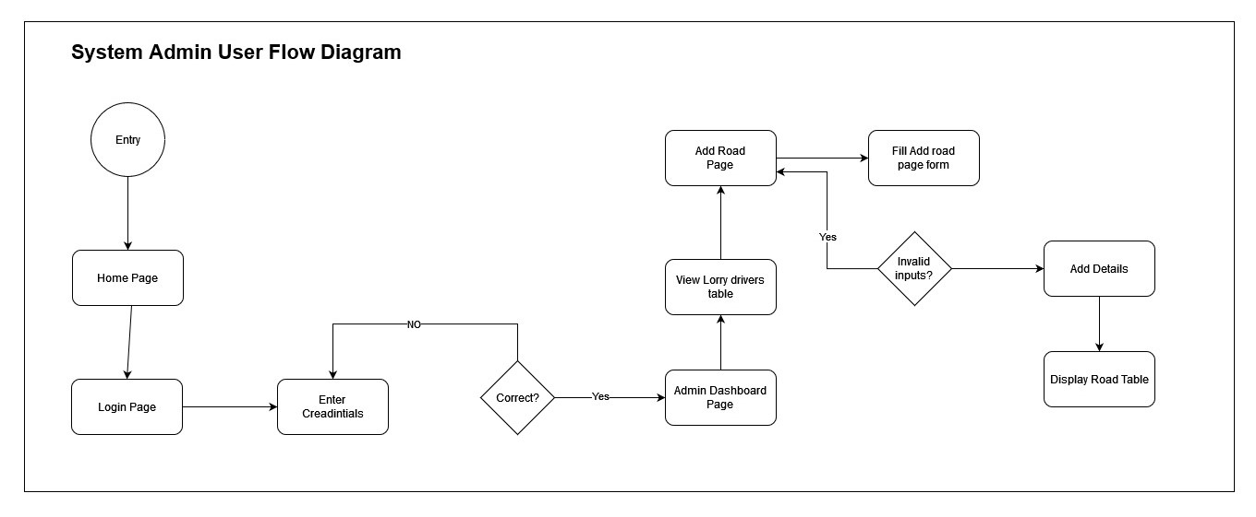

03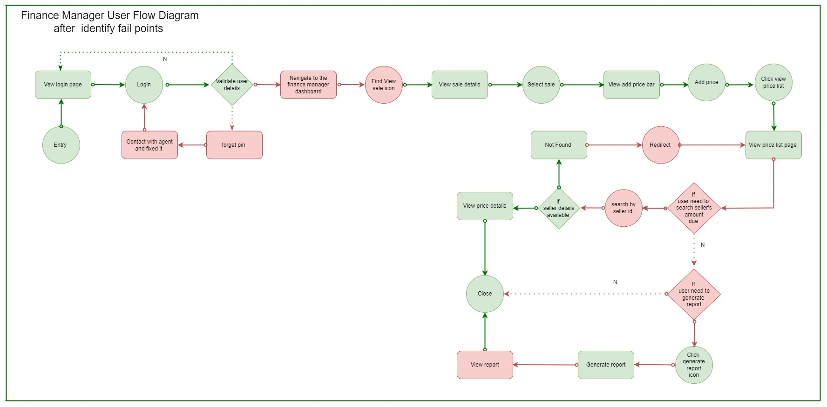

04

02

01



04

03

02

01

After completing the milestone 2, I have identified several fail points in my user flow.

In the user research, I have identified 04 blockings with referring to the interviews we have done during the user research.

In 1st diagram mentioned above I have highlighted the Fail points that I have found and the 2nd diagram represent the way that I have overcome those fail points.

I assume with related to the use research and flow of the system, that is financial manger works to the factory and system admin is the person who create user profiles by after taking details. So, I have added a finance manager onboarding scenario to my user flow.

**Fail point – 01**

The first fail point I have identified in my user flow is, not connecting the flow at the “enter user credentials” part.

The flow has been broken from this point and I have corrected the flow by adding the missing arrow.

**Fail Point -02**

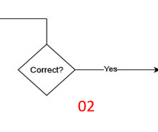



The fail point identified in this part is that I haven’t add a feature to reset the password if the password will got forgotten.

As system admin is the person who has the control over the application, I have created a reset password with the help of a one-time OTP code.

**Fail point – 03**

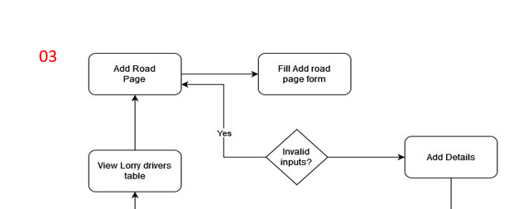

The 3rd fail point I have identified is that the validation for the lorry drivers in lorry route assigning has not done correctly. I have to assign one lorry driver only for one route. Therefore, I have corrected the flow by adding a validation to check whether the driver has been assigned previously.

**Fail point – 04**

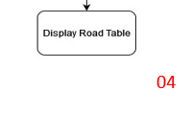

This is a main blocker point I have identified in my user flow. That is the misplacing of the close point of the diagram.

I have recorrected it by adding the closing point as shown above.

All above mentioned fail points are identified with reference to the user research

Video link: <https://drive.google.com/file/d/1oJ6Cqk-BPSyK2qPSmEL3fzwPCpvkHPjt/view?usp=sharing>

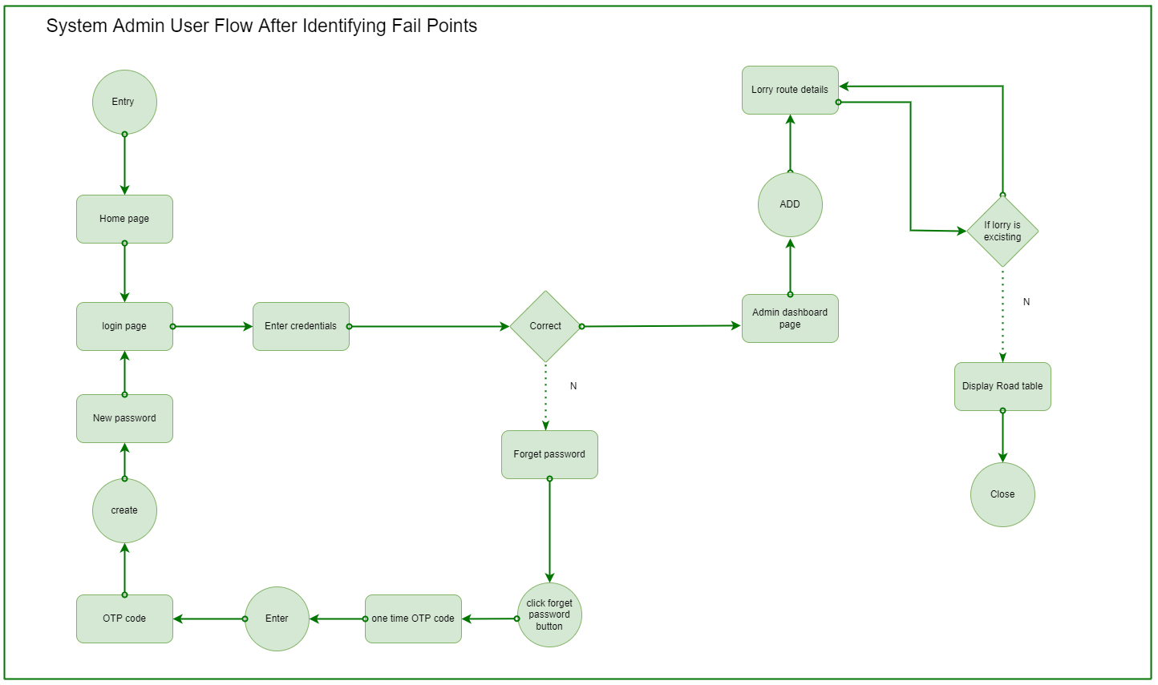User Key flows

Diagram 02

Diagram 01

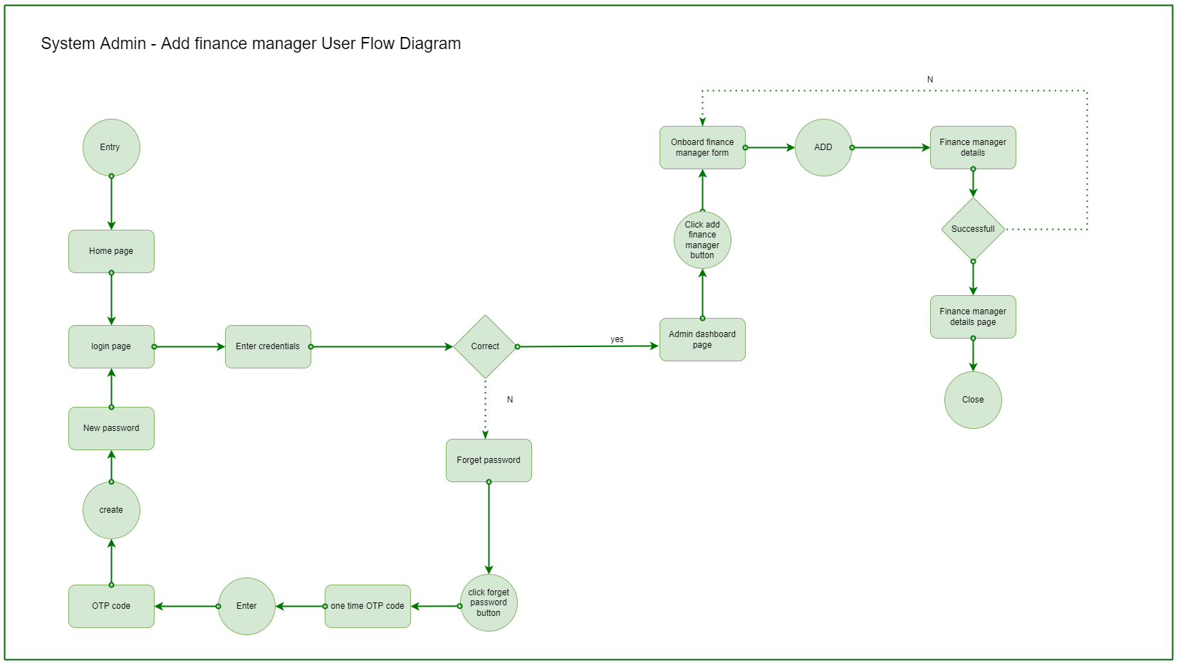

Diagram 02

Diagram 03